Work with a site template

The basic steps to working with a site template are as follows:

Save a site template to the Solutions Gallery

When you save a site template, you create a Web Solution Package file (.wsp) is that is stored in the Solutions Gallery for further use. Only the current site is saved; not any subsites below the site.

1. Navigate to the top-level site of your site collection.
2. Click **Settings** SharePoint Online Public Website Settings button and then click **Site Settings**.
3. In the **Site Actions** section, click **Save site as a template**.
4. Specify a name to use for the template file in the **File name** box.
5. Specify a name and description for the template in the **Template name** and **Template description** boxes.
6. To include the content of the site in the site template, select the **Include Content** check box. The limit is 50 MB and cannot be changed.

**Important:**Before creating a site template that includes content, check the workflow history list for the site. If there are thousands of items in the list, it may take a long time to create the site template or you may exceed the limit of 50 MB. In this case, it’s a good idea to modify the workflow association to a use new workflow history list and then delete the original workflow history list before creating the site template.

1. Click **OK** to save the template.

If all of the components on the site are valid, the template is created, and you see a message that states "Operation Completed Successfully."

1. Do one of the following:
   * To return to your site, click **OK**.
   * To go directly to the site template, click **Solutions Gallery**.

Download the site template from the Solutions Gallery

When you download your site template, you create a .wsp file that is portable and easy to use in other site collections.

1. Navigate to the top-level site of your site collection.
2. Click **Settings** SharePoint Online Public Website Settings button and then click **Site Settings**.
3. In the **Web Designer Galleries** section, click **Solutions**.
4. If it's necessary to activate the solution, select it, and in the **Commands** group, click **Activate**. Then, on the Activate Solution Confirmation screen, in the **Commands** group, click **Activate**.
5. Click its name in the solutions gallery, and click **Save**.
6. In the **Save As** dialog box, browse to the location where you want to save the solution, click **Save**, and then click **Close**.

Upload the site template to a Solutions Gallery

You can upload a .wsp file to the same site collection or different site collections in the same or different SharePoint environments.

1. Navigate to the top-level site of your site collection.
2. Click **Settings** SharePoint Online Public Website Settings button and then click **Site Settings**.
3. In the **Web Designer Galleries** section, click **Solutions**.
4. In the **Commands** group, click **Upload** or **Upload Solution**, and then in the **Add a Document** or **Add a Solution** dialog box, click **Browse**.
5. In the **Choose File to Upload** dialog box, locate the file, select it, click **Open**, and then click **OK**.
6. To activate the solution, on the Activate Solution confirmation screen, in the **Commands** group, click **Activate**.

Create a site from the site template

After you create a site template and confirm it is activated, you can create a site based on the template.

There are several ways to create a new site or subsite. You can use the SharePoint Designer or create a subsite from an existing site. Follow these steps to create a simple subsite in SharePoint using your saved site template:

**Create a subsite**

1. Click **Settings** SharePoint Online Public Website Settings button and then click **Site Settings**.
2. Click **Sites and workspaces** under **Site Administration**.

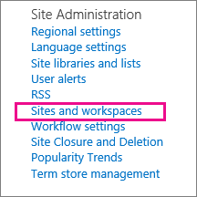

1. Click **Create** in the **Sites and Workspaces** dialog.

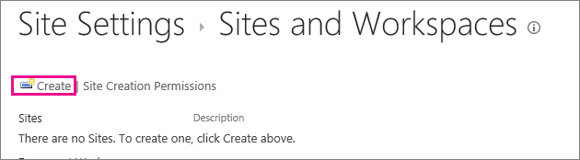

1. In the **New SharePoint Site** dialog, enter the **Title** for the page, a **Description**, and the **URL name** for users to use to get to your site.

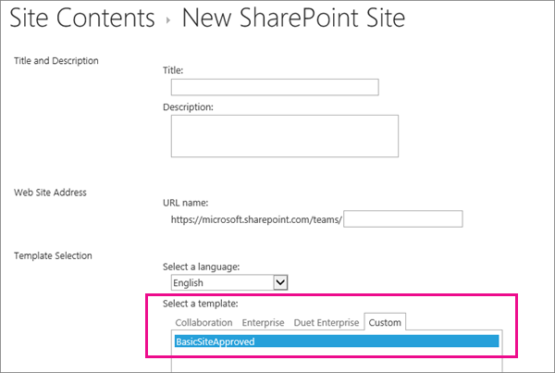

1. Under the Template Selection, click the Custom tab, and click your saved template.

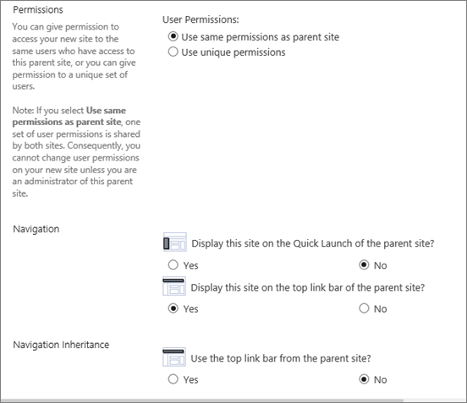

1. Select the **User Permissions** and **Navigation** options you'd prefer.
2. When you're done, click **Create**.

Manage the Solutions Gallery

You can control when a site template appears in the **Create** dialog box or its resource usage by activating and deactivating site templates in the Solution Gallery.

1. Navigate to your Solution Gallery.
2. Click **Settings** SharePoint Online Public Website Settings button , **Site Settings**, and, then under the **Web Designer Galleries** section, click **Solutions**.
3. Select a site template, and then do one of the following:
   * **Activate**    Makes the site template available for use when users create new sites through the Create dialog.
   * **Deactivate**    Removes the site template from the **Create** dialog box. A deactivated site template is unavailable for site creation and can be deleted.
   * **Delete**    Removes the site template from the Solution Gallery, but moves it into to the Recycle Bin for approximately 90 days by default before the Recycle bin is emptied. This is helpful if you later decide to restore it. If you need to delete a site template, you must deactivate it first.